Regressions with Interaction Effects

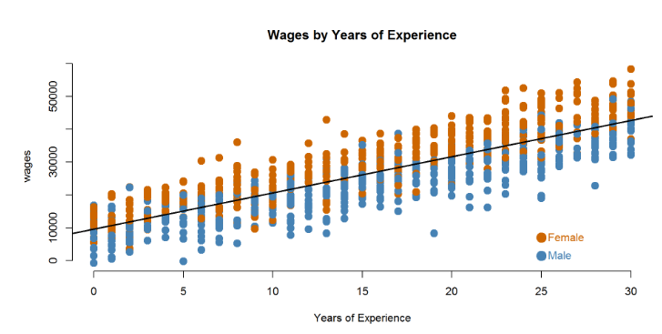

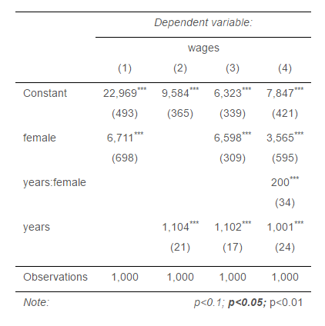
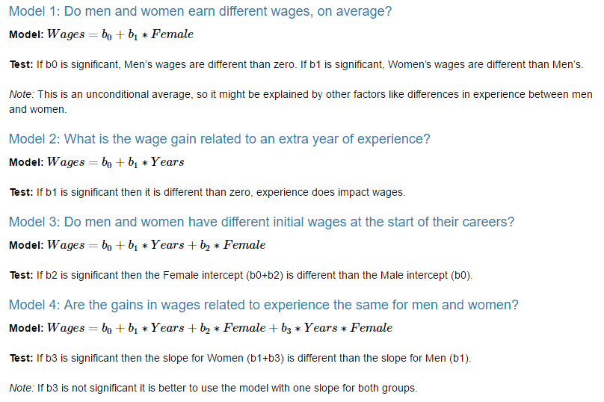

Use Model 4 to answer the following questions:

- How much do men earn in their first job (zero years of experience)?
- How much do women earn in their first job?
- What is the average raise men receive each year?
- Do men and women receive different raises? How do we know?
- What is the average raise women receive each year?

